The Application of Neural Network in Computer Control

-辽宁思凯科技股份有限公司 李硕 李晓明

Abstract—In recent years, it is a very active direction of research to use neural network to control computer. Neural network is a burgeoning crossing subject, and the way it processes information is different from the past symbolic logic system, which has some unique properties: such as the distributed storage and parallel processing of information, the unity of the information storage and information processing, and have the ability of self-organizing and self-learning. And it has been applied widespread in pattern recognition, signal processing, knowledge process, expert system, optimization, intelligent control and so on. Using neural network can deal with some problems such as complicated environment information, fuzzy background knowledge and undefined inference rules, and it allows samples to have relatively large defects and distortion, so it is a very good choice to adopt the recognizing method of neural network. This thesis discusses the application of neural network in computer control.
Keywords- neural network; computer control; application
The application of neural network in computer control developed in the late 80s of the 20th century, and it is one of the cutting edge subjects in automatic control field. It is a new subfield of intelligent control, and opens up a new way to deal with the complicated control problems which are about non-linear uncertain and unknown system. As a developing subject, it is the product of the combination of (artificial) neural network theory and control theory.

What is neural network?
1) Biological neural network model
Neuron is the elementary unit for the brain to process information. Human being’s brain has about 10¹² neurons, which have about 1000 kinds. Each neuron connects with about 10²~10⁴ other neurons and form a complex and flexible neural network. Each neuron is very simple, but the complex connections between a large number of neurons can evolve into a lot of different behavioral patterns. Meanwhile, the diverse connection types between these neurons and external receptors contain unpredictable. 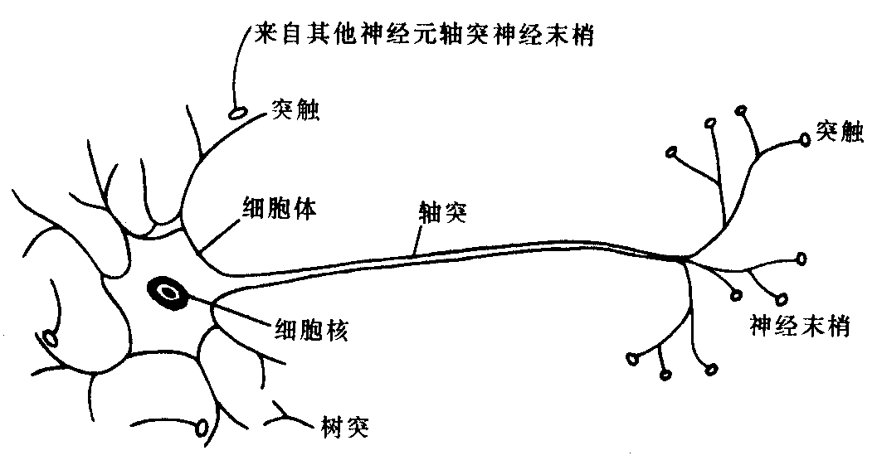
Figure 1:The structure of neuron
The process of biological neuron sending message is about many inputs and single output. In the case of the functions of each part of neuron, the processing and transmission of information mainly take place near the synapses. When the pulse amplitude passed from axon to presynaptic membrane by the cell body of neuron reaches a certain strength, that is beyond its threshold of action potential, the presynaptic membrane will release chemical substance which is for neurotransmission into the synaptic cleft. The synapses has two types: excitatory one and inhibitory one. The former produces positive postsynaptic potential, while the latter produces negative one.
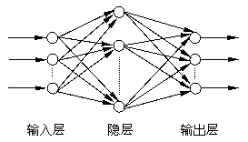
Figure 2:The structure of neuron network
2) Artificial neural network, ANN
The structure (neural network) and activity rhythm of human brain form the background of the constitution and working mechanism of the ANN. Reflecting some basic features of human brain, it is not the true representation of parts of human brain, but some abstraction, simplification and imitation. Neural network resembles human brain in two aspects:
(1)The knowledge that neural network obtains is learned from external environment.
(2)The strength of the connections of Interconnected neurons, namely synaptic weights, is used for storing the obtained information. It is both highly nonlinear dynamic system and adaptive organization system, and it can be used to describe the intelligent behaviors like cognition, decision and regulation. Neural network is the basis of parallel processing huge amount information and large scale parallel computing.

The application of neural network in computer control
1) Computer recognizes handwritten numeric characters.
In the stage of recognition, it recognizes numeric characters through input, preprocessing, feature extraction, classification and output. The numeric characters that are to be recognized are put into the host by input equipment like scanner, then it is preprocessed, and then it takes out the features of the characters by the method of some feature extraction; finally, compare the features of the characters to be recognized and those of the standard sample that is determined during the learning stage, and get the results which is then output in some way. Therefore, the processing procedure of a digital recognition system is shown in figure 3:
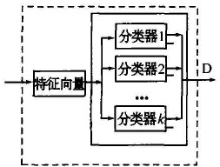
Figure 3:Processing procedure of digital recognition system
In the above-mentioned processing procedure of the recognition system, the key of the effectiveness of the recognition system lies in the extraction of characteristic vector and the design of the classifier. According to the two factors, we design the system integration in BP neural network by the classifier method based on weights integrated, and design three single classifiers which the system needs to extract different feature vectors, that is input different vectors to form different neural network classifiers according different features. Finally, test respectively the integrated designed digital recognition system and the previously designed single classifiers in the character classification identification test, and determine the properties of the system according to their recognition rates.
According to what the system requires, there are three kinds of feature vectors: original lattice feature, macroscopic feature, and microscopic feature, which are the three features need to be input in the handwritten numeral recognition system.
The whole recognition system is shown in figure 4:
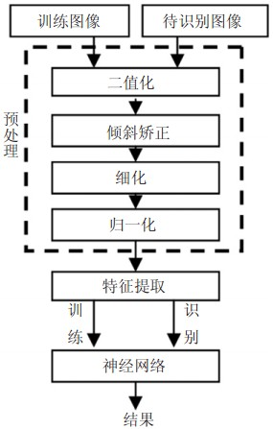
Figure 4:Handwritten digital recognition system based on BP neuron network.
The system pretreatment results finally got is shown as follows:
Before pretreatment:
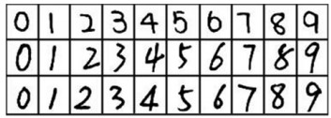
After pretreatment:
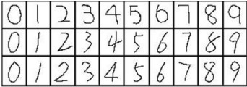
Figure 5:The pretreatment of digital recognition
Handpick one number in the picture, and after it is preprocessed, we can get the recognition result as follows:
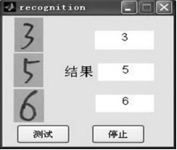
Figure 6: The results of recognition
2) Computer control tea sorting
When tea sorting, we need separate the image background of the sorted tea by the same method and obtain the eigenvalue of the tea, and then put the eigenvalue into the trained network, we can tell the category of the tea. According to the judging results, we can control the movement of the separation mechanism in the separation equipment and classify the tea.
On the basis of the thinking of tea sorting method, this paper has worked out a MATLAB program for training network and tea sorting recognition. The block diagram of the program is shown in the figure as follows: there is repeatedly single-width led tea image in both network training and the program of tea recognition, and there is only one piece of tea in each picture. When network training, it trains the tea image after it gets the eigenvalue. Finally, it generates a classified network. Considering a result of calculation may not be accurate, this paper set a ideal accuracy as the standard to determine if it needs to be recalculated. When the ideal accuracy is not certain, it can set training times, for example, after it is trained 10 times, we can choose the one with highest accuracy as the final classified network. In the tea recognition program, after we put into a tea image, we can use network to calculate and output judging results; in the experiment, the tea image is taken by camera and then import the picture file into the program: when used in the separation equipment, we can input the image taken by the camera on the equipment to the program.
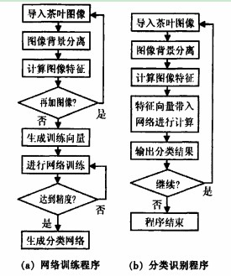
Figure 7:The Block Diagram of the program
In this study, the author has taken 100 pictures respectively from several kinds of tea, such as full-bud, one-bud-one-leave,one-bud-several-leave and so on, as samples to train, then it got classification network (train the two network respectively).Then use the trained network in the experiment of tea sorting to test the effect of the classification. There are 600 tea images involved in the experiment. The effects of the two networks are drastically different from each other. The accuracy that single output neuron network got in several training is consistent. But that of neuron network 3 differs greatly. The results of the experiment are shown in table1 and table2.
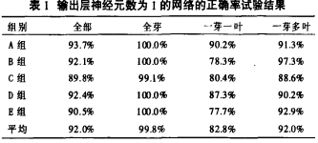
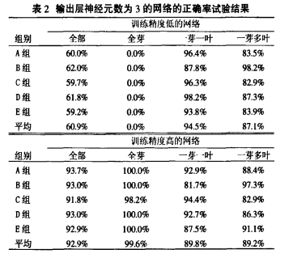

References

- Fan Caixia, Liang Wenquan. Neuron Network Optimizes Synchronously HPMC Sustained-Release Tablets with Multiply Tar［J］.Chinese Journal of Pharmaceuticals, 2004, 39（10）:768－771.
- Zhang Yufei, Shao Xiuli, Lei Jianjun. The Modeling and optimization of the process of the TCM preparation Based on Neuron Network and genetic algorithm［J］. Computer Engineering and Applications, 2005,2(2):194-195
- Li Lingbing, Zhang Na. Design Clozapine Non-PH-Relied Sustained Release Tablets Using Artificial Neuron Network Combined with Pharmacokinetics Model［J］. Chinese Journal of Pharmaceuticals,2005,40 (17)
- Wei Xiaohong, Wu Jianjun, Liang Wenquan. The Application of Neuron Network in the Formulation Design of the Preparation with Good Release Characters［J］. Acta Pharm Sin, 2001,36（9）：690-694.

